Civil war in [Rwanda]

UNSC Resolution: | 1161
Date of adoption: | 9-April-1998
Operative paragraph: | 03
Demand number: | 1161.0311

[Philippe Rieder]

Wording of demand
Cooperate fully with the Commission in the fullfilment of its mandate, including by responding positively to requests from the Commission for security,

List of addressees of the demand

Government of Rwanda, neighbouring states

Short-term compliance

Description of the addressee(s)’ conduct

“The investigative team's report states that the Democratic Republic of the Congo had no intentions of accepting the mission of the team and failed to give its full cooperation. The team was, nevertheless, able to confirm that certain types of violations occurred in certain regions at certain times. The report outlines numerous violations of international humanitarian law and possible crimes against humanity.” (Security Council Press Release, (SC/6545) 13 July 1998, on: http://www.un.org/News/Press/docs/1998/19980713.sc6545.html September 2009))

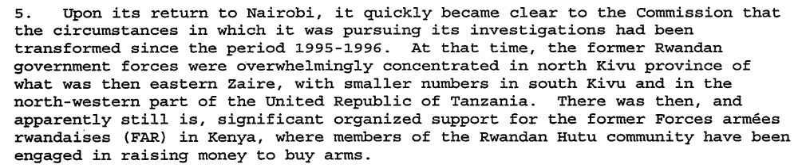
(Interim Report of the International Commission of Inquiry, in: Annex of Letter dated 18 August 1998 from the Secretary-General to the President of the Security Council, (S/1998/777), 19 August 1998, p. 3)

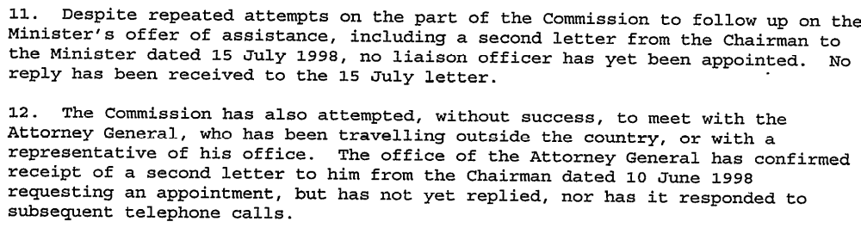
(Activities of the Commission in Kenya - Interim Report of the International Commission of Inquiry, in: Annex of Letter dated 18 August 1998 from the Secretary-General to the President of the Security Council, (S/1998/777), 19 August 1998, p. 3)
“Upon learning of those accounts [documents found by the Banyamulenge after the attack on Mugunga camp 1996], the Chairman had written to the Government of Rwanda, on 21 November 1996, requesting the Commission’s access to the documents reportedly found at the camp. At his meeting with Minister Habyarimana, the Chairman requested to be allowed to examine the documents, to inspect weapons seized in recent engagements between the Rwandan Patriotic Army (RPA) and insurgents, and to interview some of the captured insurgents. The Chairman also requested that a liaison officer be designated to assist the Commission. At the invitation of the Government, the Chairman subsequently put his requests in writing.
23. The liaison officer appointed by the Government, Lt.-Col. Patrick Karegeya, the Chief of External Intelligence of RPA, promised the cooperation of his Government to the extent possible without compromising sensitive intelligence sources and operations. At his invitation, the Commission has begun to study some of the documents seized at Mugunga camp in November 1996. However, according to Lt.-Col. Karegeya, many documents were removed by journalists at the time and are not in the possession of the Rwandan Government.” (Interim Report of the International Commission of Inquiry, in: Annex of Letter dated 18 August 1998 from the Secretary-General to the President of the Security Council, (S/1998/777), 19 August 1998, p. 4f)

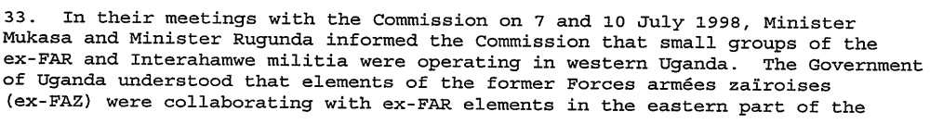
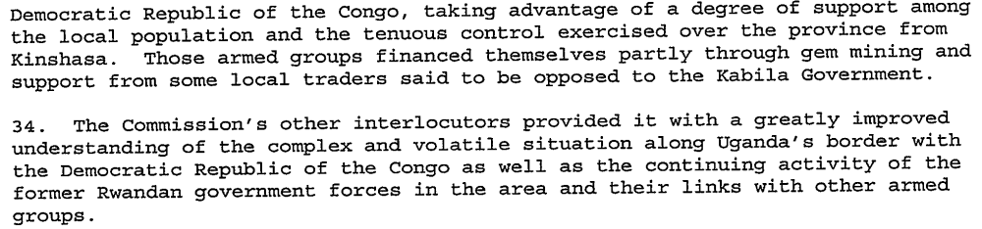
(Interim Report of the International Commission of Inquiry, in: Annex of Letter dated 18 August 1998 from the Secretary-General to the President of the Security Council, (S/1998/777), 19 August 1998, p. 6f)

Assessment

Short-term compliance
No or marginal compliance (1) | Medium low compliance (2) | X Medium high compliance (3) | Full or almost full compliance (4)

Considerations underlying the assessment

The cooperation with the Commission of Inquiry was predominantly good, especially in countries such as Uganda and Rwanda, who still were fighting the Ex-FAR and its successor organization, the ALiR, whose arms supplies the Commission targeted. Cooperation with Kabila’s DRC although proved very unsatisfying as the DRC employed the Ex-FAR as proxy forces against the Rwandan and Ugandan invaders.

Medium-term compliance

Description of the addressee(s)’ conduct

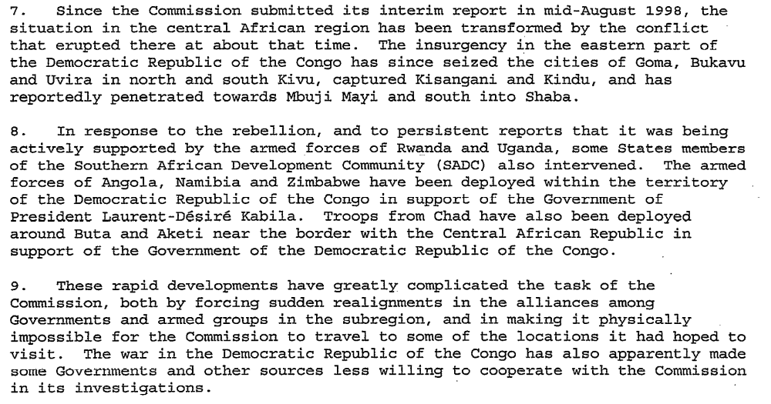
(Final Report of the International Commission of Inquiry, in : Annex of Letter dated 18 November 1998 from the Secretary-General to the President of the Security Council, (S/1998/1096), 18 November 1998, p. 3)

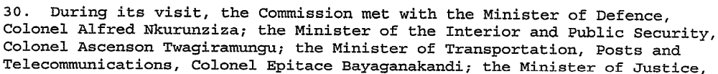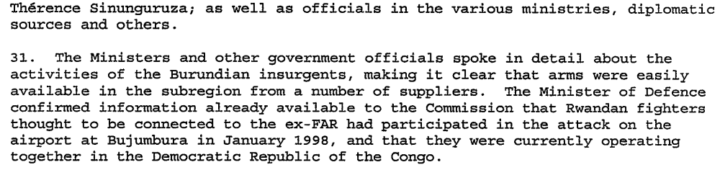
(Final Report of the International Commission of Inquiry, in: Annex of Letter dated 18 November 1998 from the Secretary-General to the President of the Security Council, (S/1998/1096), 18 November 1998, p. 8f)

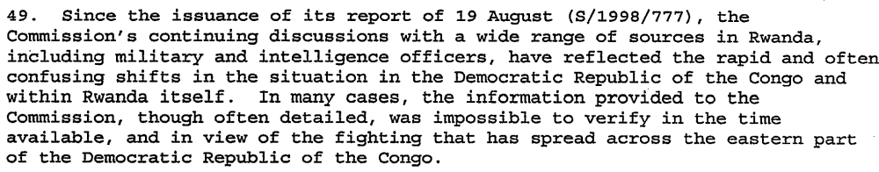
(Final Report of the International Commission of Inquiry, in: Annex of Letter dated 18 November 1998 from the Secretary-General to the President of the Security Council, (S/1998/1096), 18 November 1998, p. 11)
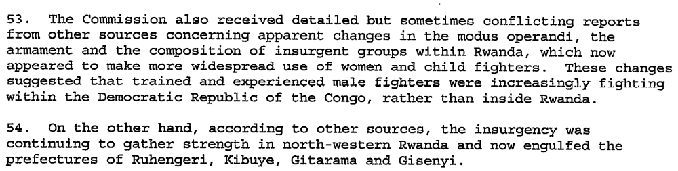
(Final Report of the International Commission of Inquiry, in: Annex of Letter dated 18 November 1998 from the Secretary-General to the President of the Security Council, (S/1998/1096), 18 November 1998, p. 11)

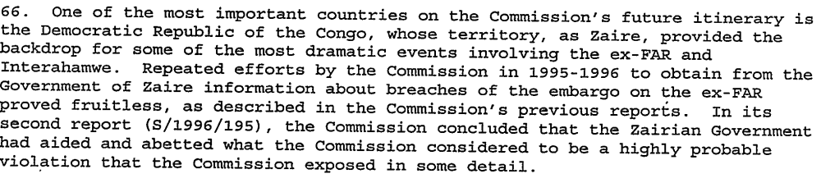
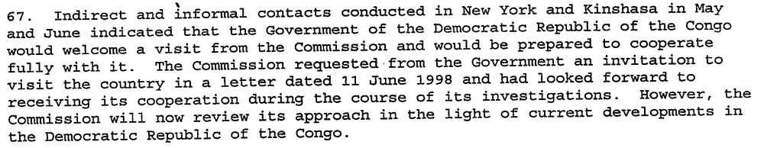
(Final Report of the International Commission of Inquiry, in: Annex of Letter dated 18 November 1998 from the Secretary-General to the President of the Security Council, (S/1998/1096), 18 November 1998, p. 14f)

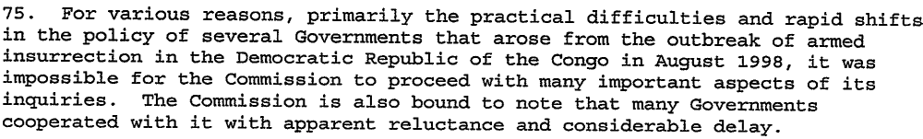
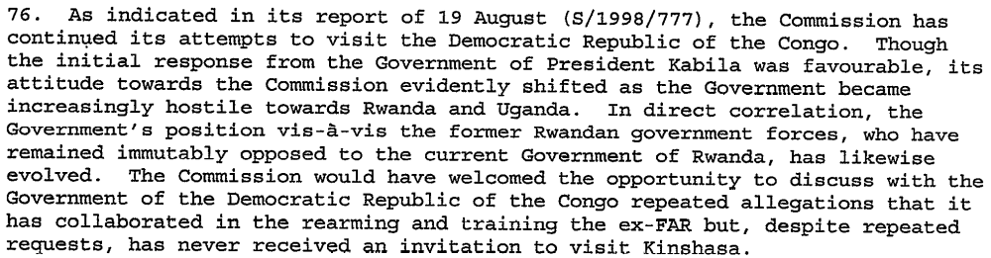
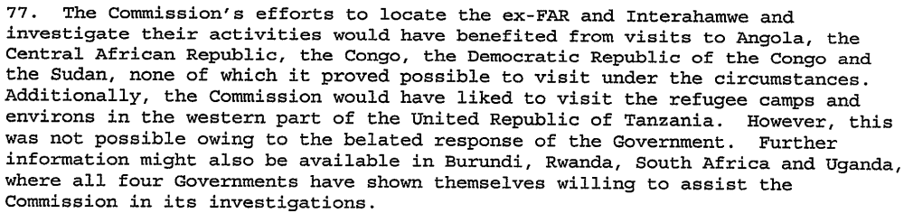
(Final Report of the International Commission of Inquiry, in: Annex of Letter dated 18 November 1998 from the Secretary-General to the President of the Security Council, (S/1998/1096), 18 November 1998, p. 16)

“He [the Representative of the USA, in the UNSC meeting of 19 March 1999] stated that the United Nations investigative reports had pointed towards atrocities and violations of international humanitarian law in the Congo since 1996 and that the Government and other parties had failed to cooperate with United Nations efforts to investigate those abuses. In that regard, he welcomed the Congolese Government’s recent invitation to the United Nations human rights investigator. He called on members of the international community to redouble their efforts to limit arms flows to the region of conflict, called for safe and unhindered access for humanitarian agencies to all those in need and for all parties to guarantee the safety and security of United Nations and humanitarian personnel.” (Items relating to the Democratic Republic of the Congo, in: Repertoire of the UNSC, 13th Supplement – Chapter VIII, 1997-1999, p. 20)

Efforts by the Secretary-General, the Organization of African Unity (OAU) and the Southern African Development Community (SADC) led in July 1999 to the Lusaka Ceasefire Agreement. Signed by the Democratic Republic of the Congo, along with Angola, Namibia, Rwanda, Uganda and Zimbabwe, it provided for an end of hostilities and for the holding of an inter-Congolese dialogue. The "Lusaka Agreement" included provisions for the normalization of the situation along the border; the control of illicit arms trafficking and infiltration of armed groups; the holding of a national dialogue; and the establishment of a mechanism for disarming militias and armed groups. (Security Council Press Release (SC/7057), 30 May 2001, http://www.un.org/News/Press/docs/2001/sc7057.doc.htm (23 September 2009))

“CAMERON R.HUME (United States) said the implementation of the Lusaka Agreement had been a roller coaster. While the ceasefire was holding, for example, the forces of principal belligerents still remained in place. The humanitarian and human rights situations had also not improved and that was an area of great concern. Negative forces continued to receive arms and there was still a propensity to violence in some areas. Some forces also seemed to be receiving support from elements in the Government of the Democratic Republic of the Congo, while Kisangani had yet to de demilitarized. In addition, a relevant and credible political plan for the disengagement of forces was yet to be presented.” ((Security Council Press Release (SC/7132), 30 August 2001, http://www.un.org/News/Press/docs/2001/SC7132.doc.htm (23 September 2009))

“The Security Council, (…)
Stressing the importance of the cooperation of all States, in particular those in the region, with the Security Council Committees established pursuant to resolutions 918 (1994) and 1533 (2004) and with the Group of Experts established by resolution 1533 (2004), while carrying out its mandate as renewed by resolution
1698 (2006), Stressing further the need for States in the region to ensure that arms and related materiel delivered to them are not diverted to or used by illegal armed groups,(…)
Decides to terminate with immediate effect the measures imposed by paragraph 11 of resolution 1011 (1995);” (Security Council Resolution 1749 (2007), (S/RES/2007/1749), 28 March 2007)

Assessment

Medium-term compliance
No or marginal compliance (1) | Medium low compliance (2) | X Medium high compliance (3) | Full or almost full compliance (4)

Considerations underlying the assessment

The attitudes did not change much. The countries supporting the ex-FAR, such as the DRC remained reluctant to cooperation with the Commission whereas countries fighting the Ex-FAR, such as Rwanda, Burundi and Uganda welcomed the investigations as far as they did not touch their own interests.

Depth of Demand

Assessment

Level of depth of demand
Low depth of demand (1) | X Medium depth of demand (2) | High depth of demand (3)

Considerations underlying the assessment

Practically all forces engaged in the First and Second Congo War supplied armed groups as proxy forces with arms. As the embargo essentially targeted the Ex-FAR, Rwanda had an interest in the work of the Commission and thus for Rwanda, the depth would be low. On the other hand, Kabila started to support the Ex-FAR after breaking up the ties with Rwanda. Thus for DRC, the depth would have been high.

Level of confidence about coding decisions

Level of confidence about coding decision
Extremely high | High | X Moderate

Comments to IPI (if any)

